Computer Language Coding Concepts

Attributes in a Diagram
The principle of attributes is explained in the article Attributes. The current article explains its expression in a diagram.

An attribute is value stored inside an object. An attribute is actually a sub-object with special properties, as explained in the article Attributes. Because an attribute is an object, it is represented by a circle drawn with a solid line.

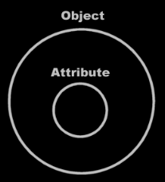

An attribute is often an object of a simple nature, for instance a number, a date or a simple piece of text. The value is textually expressed. An object’s literal value is shown inside the object, usually in the center of the symbol:

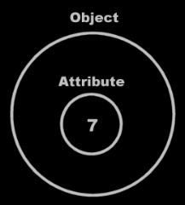

Or closer to the top of the symbol if any other symbols are shown inside the attribute.

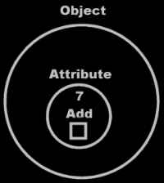

Author & Copyright: Jan-Joost van Zon Date: May 21, 2008 – May 21, 2008 Location: Oosterhout, The Netherlands Status: Finished

